UNACADEMY

To provide digital education for all types of learners.



Prepared By:

* Hari Priya Kotagiri
* Imran shaik
* Akhila seri
* Rukma Reddy Battu
* Hareesh Dasari

**University of Colorado Denver**

**ISMG 6450- SUMMER 2022**

**Professor- Bob Kois**

**Table Of Contents:**

1. Introduction
2. Executive Summary
3. Project Scope Management – (Hareesh Dasari)
   1. Scope Statement
   2. Product Description
   3. Project Team Members
   4. Team Organization Chart
   5. Work Structure Breakdown
4. Schedule Management (Hareesh Dasari)
   1. Schedule Management Plan
   2. Sequence of Activities
   3. Gantt Chart
5. Project Cost Management (Imran)
6. Project Quality Management
   1. Quality Checklist
7. Risk Management – (Hari Priya)
   1. Risk Management Plan
   2. Monitor and control risk.
8. Resource Management Plan (Hari Priya)
   1. Organizational Structure
   2. Resource Estimation and Acquisition
   3. Resource Team Management
9. Communication Management (Rukma)
10. Integration Management (Rukma)
11. Stakeholder Management (Akhila)
    1. Identify stakeholders.
    2. Plan stakeholder engagement
    3. Manage stakeholder engagement.
    4. Monitor stakeholder engagement
12. Project Procurement Management (Akhila)
    1. Planned procurement management.
    2. Conduct Procurements
    3. Control procurements
    4. Close procurements
13. Key Takeaways
14. Conclusion
15. **Introduction:**

Unacademy is an online website service which provides affordable and quality education by utilizing the modern means of technology and internet. This has been a revolutionary concept where it connects people who are eager to learn and passion to teach. Unacademy is like jack of all trades where specialist educators from various fields are come together and teach in a creative way and in 2018 it has become one of the best startup awards awarded to it by govt of India commerce ministry.

Unacademy has two kinds of services.

* Unacademy free where it provides free classes and other material free of cost. These materials are provided solely depending on the educators wish.
* Unacademy plus which is a subscription-based services where a nominal fee is charged which directly motivates the educators to improve their quality of service provided.

There are many instances where unacademy has proven successful where many people who doesn’t have access to formal education by utilizing the free services provided by unacademy people has cracked the world’s toughest exam which is civil services in India.

1. **Executive summary:**

For this project the detailed budget is planned out along with the Gantt chart. The budget gives the complete detailing of the costs which are being incurred for various stages of development. The milestones are listed appropriately so that each stage of development can be determined. Communication plays a crucial role in the success of a project. The communication plan with the help of which this project is planned to become successful is demonstrated. The scope of this project along with the integration strategies are understood completely here so that the working and the rundown takes place smoothly. To add on the resource management and risk management aspects are described clearly to understand the threats that the project is going to experience. Apart from that the severity of the risks is also determined along with the preventive measures which can be adopted to mitigate the risk. The resources can witness using the Gantt chart as well. It basically defines the connectivity of work between the source points of work. Lastly it is essential to build a communication channel so that all the participants and their works flow can be smooth. It is essential that all the stakeholders are engaged properly. All the stakeholders are continuously engaged with the project with respect to the updates and feedback on a regular manner and the detailed stakeholder management plan is devised to engage and monitor the stakeholder activity.

1. **Project Scope Management**
   1. **Scope Statement**: Unacademy is intended as an accessibility tool to provide a platform but not to replace formal education system, it was created to reform the current learning method at affordable cost and accessibility to all sections irrespective of their social, economic, cultural, geographical boundaries. This project requires a teams which includes developer, UX/UI designer, stakeholder, manager , stakeholder , IT Support etc. to successfully design , develop this tool and major participants like tester and other team members before the deployment of the website. This platform can also be used to live telecast the lectures or course content via many kind of major platforms like YouTube, Instagram, twitch etc. . In order to do that a specific functionality should be placed in the algorithm. Unacademy module should be developed in compliance with PCI-DSS standards, data privacy & security laws according to the region specific.
   2. **Product description:** Unacademy is an innovative and comprehensive educational platform that aims to revolutionize the way people learn and acquire knowledge. It is designed to provide high-quality education to learners of all ages and backgrounds, offering a wide range of courses and study materials across various subjects.

With Unacademy, learners can access a vast library of video lectures, live classes, and interactive quizzes, all delivered by expert educators and professionals in their respective fields. The platform covers a diverse range of subjects, including but not limited to academics, competitive exams, language learning, coding, business, arts, and personal development.

One of the key features of Unacademy is its interactive and engaging learning experience. Learners can ask questions, participate in discussions, and receive personalized feedback from instructors, creating an environment that fosters active learning and knowledge retention.

Unacademy also offers a flexible learning approach, allowing users to learn at their own pace and convenience. Whether you prefer to study in the early morning or late at night, the platform provides 24/7 access to educational content, ensuring that learning fits seamlessly into your schedule.

Additionally, Unacademy provides comprehensive exam preparation resources for various competitive exams, such as UPSC, SSC, IIT-JEE, NEET, CAT, and more. These resources include curated study materials, mock tests, previous year's question papers, and expert guidance to help learners excel in their exams.

The platform is accessible on multiple devices, including smartphones, tablets, and computers, enabling users to learn anytime, anywhere. Unacademy also offers a user-friendly interface and intuitive navigation, making it easy for learners to explore and access the content they need.

Unacademy is dedicated to democratizing education and making it accessible to all. It offers both free and subscription-based plans, allowing learners to choose the option that suits their needs and budget. The free plan provides access to a wide range of content, while the subscription plan offers additional features and benefits, such as ad-free viewing, live doubt-solving sessions, and personalized learning paths.

In summary, Unacademy is a cutting-edge educational platform that brings together passionate educators, comprehensive study materials, and interactive learning tools to empower learners and help them achieve their academic and career goals.



* 1. **Project Team Members:**

This Project requires full-scale planning , development, design, testing, integration, along with IT Support as well.

1. Approach & planning: Create an intuitive website for Unacademy with a user-friendly interface, interactive features, comprehensive course offerings, expert educators, and flexible learning options to deliver a seamless and engaging educational experience.
2. Development: During the development phase of creating the Unacademy website, focus on designing a responsive layout, integrating video lectures, implementing interactive features, optimizing performance, and ensuring a smooth user experience.
3. Testing and Feedback: In the testing and feedback phase of creating the Unacademy website, conduct rigorous testing to identify and fix bugs, gather user feedback, and make necessary improvements to enhance usability, functionality, and overall user satisfaction.
4. Stakeholder: Stakeholders in creating the Unacademy website include educators, developers, designers, content creators, administrators, and learners, all collaborating to ensure the platform meets their needs and goals.
5. Deployment: During the deployment phase of creating the Unacademy website, the finalized website is launched on a server, configured for optimal performance, and made accessible to users, ensuring a seamless and reliable online learning experience.
6. End User: During the final user review and public testing phase of creating the Unacademy website, real users test the platform, provide feedback, and identify any remaining issues to ensure a refined and user-centric experience before the official launch.
7. IT Support: IT support plays a crucial role in creating the Unacademy website by providing technical expertise, resolving technical issues, ensuring server maintenance, and optimizing the website's performance and security.
   1. **Team Organizational Chart:**

Stake Holder

Analyst Team

Deploying

Testing Team

Development Team

End User

IT Support

* 1. **Work Structure Breakdown:**

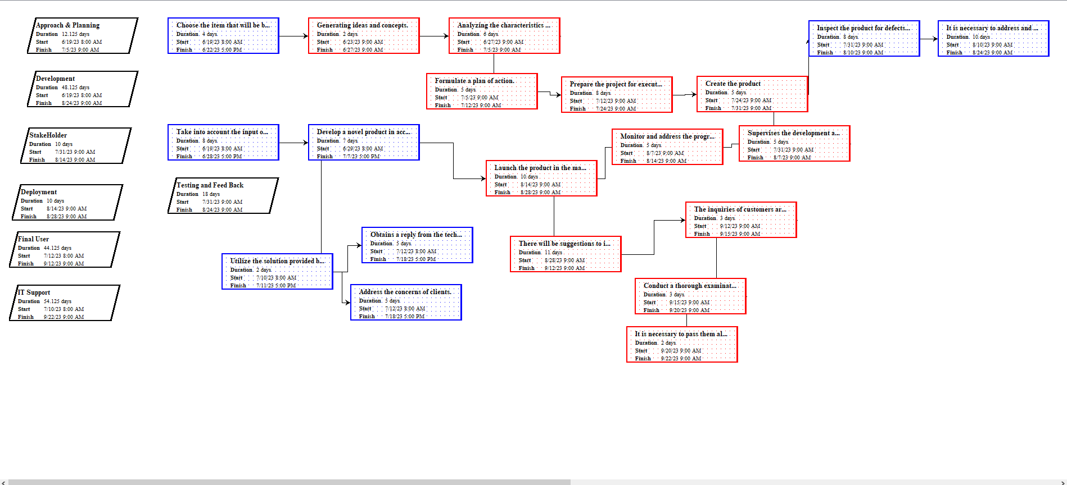

1. **Schedule Management:**
   1. **Schedule Management Plan**: The schedule management plan outlines the project's strategy for managing and controlling timelines. It provides a comprehensive overview of the plan's objectives, including planning, development, execution, management, and monitoring. The tables below provide details of the project's milestones and their respective durations.

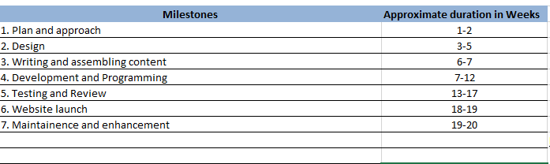

* 1. **Sequence of Activities:**

IT Support assistance

Deployment

Testing and Review

Development

Designing

Software and design requirement specification

Data collection , Analysis

Review and Feedback

This Project is estimated to be completed in 20weeks with a variation of + or -10 days. This project has developer and designer dependencies since the developing of the module requires expertise from different teams and other developers .

Schedule Development and Control:

The schedule management plan outlines the project's strategy for managing and controlling timelines. It provides a comprehensive overview of the plan's objectives, including planning, development, execution, management, and monitoring. The tables below provide details of the project's milestones and their respective durations.

* 1. **Gantt Chart:**

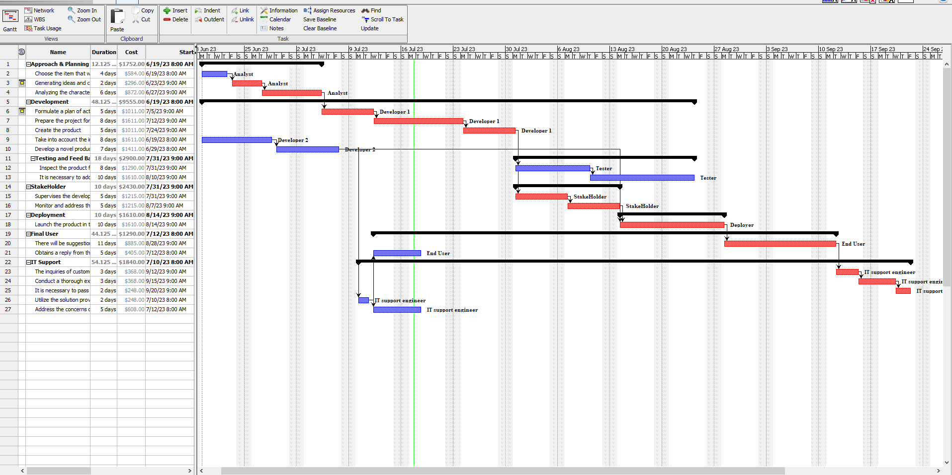

1. **Project Cost Management:**

Cost management is a vital process that involves organizing and supervising a project's budget. It plays a crucial role in helping project managers estimate costs accurately and implement controls to minimize the risk of exceeding the budget. As projects typically require resources like manpower, supplies, and equipment, cost management becomes essential to ensure efficient allocation and utilization of these assets while keeping expenses in check. Effective cost management is crucial throughout the project's lifespan to predict, monitor, and manage expenses to successfully complete the project within budget constraints.

Cost management offers several key benefits, including:

- Avoiding cost overruns: By carefully analyzing and controlling expenses from the outset, project managers can prevent overspending in specific areas.

- Risk mitigation: Establishing a well-defined budget helps businesses maintain project momentum, even when unexpected expenses arise, reducing the impact of financial risks.

- Future planning support: Effective organization of resources enables the creation of accurate budgets for future projects, aiding in better planning and allocation of resources.

Resource planning, Cost estimate, Cost budgeting, and Cost control are the four stages of cost management, which can be broken down into a continuous process if necessary.

1. Resource planning is the process of identifying and allocating the necessary resources required to execute and complete a project. It is conducted prior to commencing substantial work on the project, allowing project managers to create a detailed inventory of resources. This task-level technique provides insights for the subsequent stage of cost estimation.
2. Cost estimation involves determining the anticipated expenses associated with acquiring all the necessary materials to complete a project. This process is particularly challenging as it requires a high level of accuracy. Project managers need to consider fixed and variable costs, overhead expenses, inflationary factors, and the concept of time value of money during the estimation process.

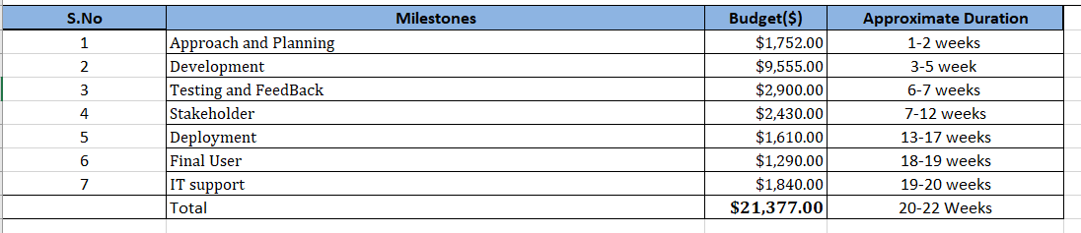

1. Cost Budgeting: Cost budgeting is a distinct process that involves allocating expenses to specific portions of a project, such as activities or units, for a predetermined period. It can be considered a part of the estimation process or a separate procedure. Budgets often include contingency funds to address unexpected expenses.

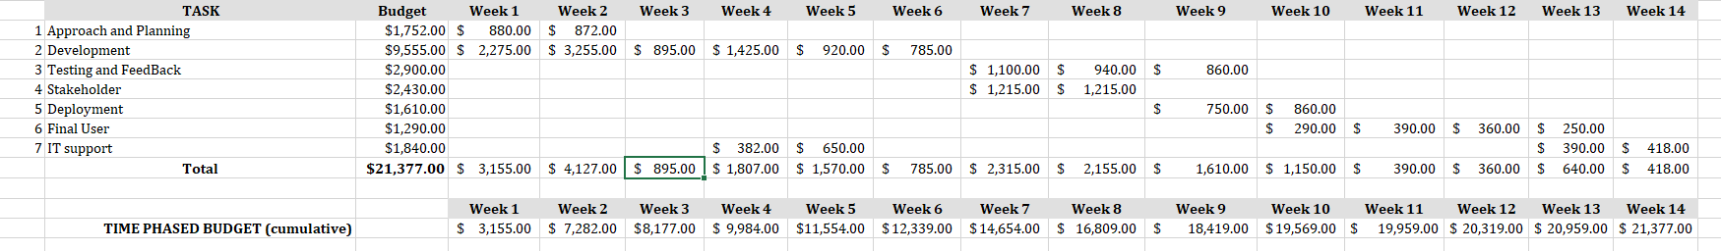

1. Cost control is the process of identifying deviations from the baseline costs and implementing measures to mitigate them, such as adjusting the budget or modifying the project scope. It is an ongoing activity in cost management, requiring accurate measurement and timely reporting. One common approach is creating an S curve for cost planning, which tracks the overall budget and cumulative value over time.

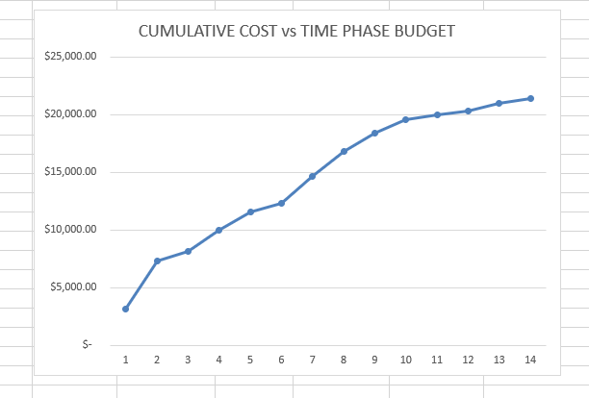

1. **Project Quality Management:**

Project quality management for Unacademy ensures that high standards are maintained throughout the development process. It includes activities such as defining quality metrics, conducting regular inspections, implementing quality control measures, ensuring adherence to standards, and continuously improving the platform to deliver an exceptional learning experience.

These three procedures make up project quality management:

1. Quality planning involves identifying potential risks, setting high standards, organizing processes, and defining testing procedures to ensure performance achievement, control, anticipation, and verification. It is crucial to assign responsible individuals or task forces to oversee and monitor quality metrics within the project's quality management activities.
2. Quality assurance in the creation of the Unacademy project involves systematic processes and activities to ensure that the developed platform meets the defined quality standards. It includes conducting regular audits, inspections, and tests, implementing quality control measures, and continuously improving the platform's functionality, usability, and overall user experience.
3. Quality control refers to the operational techniques employed to ensure adherence to quality standards. It involves identifying, examining, and resolving issues that may arise. Quality control monitors specific project outcomes, assesses compliance with applicable standards, analyzes risk factors, plans mitigation strategies, and seeks solutions to prevent and eliminate subpar performance.
   1. **Quality Checklist:** A quality checklist is a vital component of project management quality assurance, ensuring the monitoring and recording of deliverable quality. It serves as a systematic tool to verify successful implementation of necessary improvements and advancements. The checklist can range from simple to extensive, depending on project requirements and procedures. It applies to all team members and can be used to verify individual sub-tasks. Additional space is provided for future additions based on project circumstances. The following are examples of quality checklists: [Include the specific quality checklists].

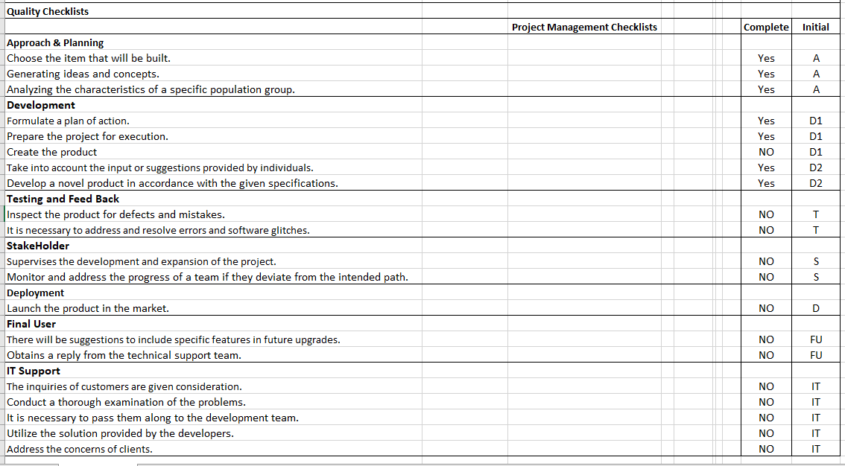

1. **Risk Management**
   1. **Risk Management Plan:** Risk management is the practice of identifying, evaluating, and mitigating or reducing potential risks that could impact a project's desired outcomes. Project managers are responsible for overseeing the risk management process throughout the entire project duration.

Risk management involves seven key activities: requirement collection, software and design, designing schematics, developers' architecture, testing, support and end user satisfaction, and review and feedback. Each activity is assigned a probability (ranging from 1-10) and consequence (ranging from 1-10). Mitigation plans are developed to address these risks. Risks are categorized as high, medium, or low, represented by the colors red, yellow, and green, respectively.

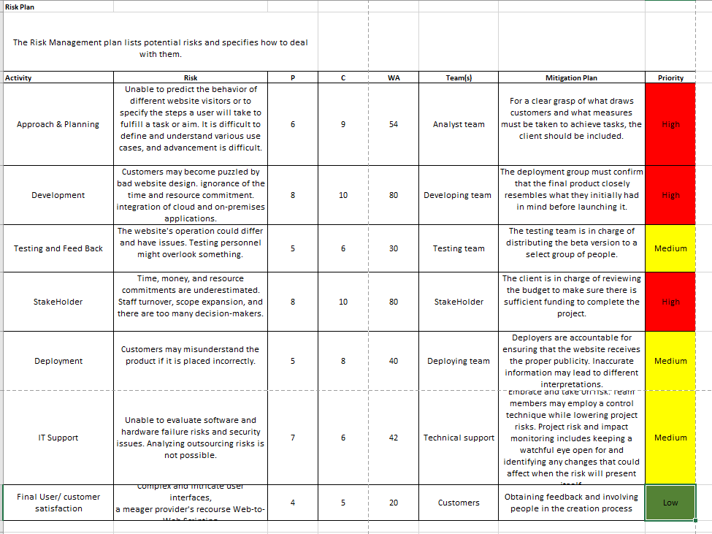

Project managers must be mindful of the various risks they may encounter, which can vary depending on the project type. However, there are common risk categories that apply to most projects:

1. Cost: The potential for occurrences that can impact the project budget, particularly leading to higher-than-expected costs. Risk in this category often arises from errors in cost estimation and external factors.

2. Schedule: The possibility of unexpected scheduling conflicts or delays that can hinder project completion. Schedule conflicts and delays are often caused by scope creep, where the project scope expands beyond the original plan.

3. Performance: The likelihood of events or factors that can result in the project delivering outcomes that do not meet the project requirements or expectations.

These risk categories are prevalent across projects and project managers should proactively address them to ensure successful project execution and delivery.

* 1. **Monitor and control Risk:**

The process of monitoring and controlling risks involves executing response plans, continuously tracking identified risks, identifying and addressing new risks as they arise, and enhancing risk management procedures. It also includes evaluating the effectiveness of implemented risk response plans, identifying potential risk factors within the project, assessing the need for modifications or closure of existing risks, and maintaining vigilance over ongoing risks.

1. **Resource Management Plan:**

The resource management plan encompasses not just task assignment, but also ensuring the availability of internal resources based on their expertise. It involves creating a Responsibility Matrix to clearly define the responsibilities of each team member for their assigned tasks. The plan also outlines milestones and specifies the responsible individuals, their accountability, participation, and information sharing.

Resource Project Management: The resource management plan is critical for project success as it involves planning, organizing, managing, and evaluating the efforts of project resources. Its goal is to effectively allocate, schedule, and utilize resources within the organization. The project manager must ensure adequate resources are allocated to specific process procedures. This involves following procedural stages, such as creating a comprehensive plan that considers the required number of employees and their availability for project delivery, monitoring resource utilization, and conducting regular team meetings to track progress and recognize achievements.

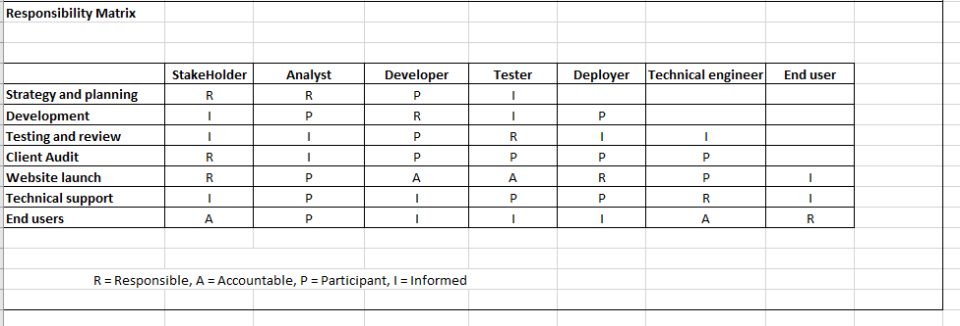

* 1. **Organizational Structure:**

An organizational structure serves as a blueprint or framework for effectively carrying out tasks. It establishes procedures that act as a roadmap for achieving business success. By depicting the distribution of power and information within the company, it facilitates clarity regarding roles, responsibilities, and accountability for everyone involved.

Stakeholder

Project manager

Tester

Developer 1

analyst

IT Support

Developer 2

End User

Deployer

* 1. **Resource Estimation & Acquisition:**

Resource estimation involves allocating the required resources to specific project activities, encompassing not just the necessary skill sets but also hardware equipment and software needed for project completion. The project manager holds the responsibility of estimating and finalizing the resources required for the project, including identifying additional resources like backup analysis. The aim is to ensure proper allocation of resources for successful project execution.

Resource acquisition primarily involves four steps:

• Selection of necessary resources.

• Procurement of resources.

• Management and control of resources.

• Efficient utilization of resources.

Resource acquisition entails identifying and procuring the required resources while ensuring their optimal use. The aim is to prevent resource wastage and avoid obtaining excess resources, ultimately reducing project costs.

* 1. **Resource Team Management:**

The management team actively engages in weekly reviews and team performance evaluations, providing necessary training to enhance skill sets as needed. Issues are addressed promptly, ensuring projects are completed on schedule and within budget. Resource management is essential for effective planning and allocation of resources, anticipating their quantity requirements. It promotes efficiency, prevents burnout, ensures resource availability, and enhances transparency. A resource management strategy enables project managers to monitor capacity, schedules, and utilization rates. This helps businesses ensure sufficient personnel for each task and avoid overburdening the team. By filtering and categorizing resources based on skill sets, resource management prevents potential issues. Platforms like Teamwork allow project managers to quickly assess resource availability and suitability for new projects.

1. **COMMUNICATION MANAGEMENT:**

Communication management is an integral aspect of any project, serving as its foundation. A well-established communication plan is essential for effective project implementation. It involves various hardware and software activities and is crucial for decision-making processes. Communication, whether direct or indirect, significantly influences project decisions and has the power to build or break relationships. Different modes of communication, such as verbal, written, or digital, can have distinct impacts on the project environment. The team should engage in multiple sessions to understand progress and exchange diverse perspectives. Weekly reports and idea sharing enhance clarity on project progress and facilitate development tracking.

The communication plan for the Unacademy team, an affordable and accessible educational platform, involves establishing effective communication channels with all stakeholders, including regular updates on minor developments and progress.

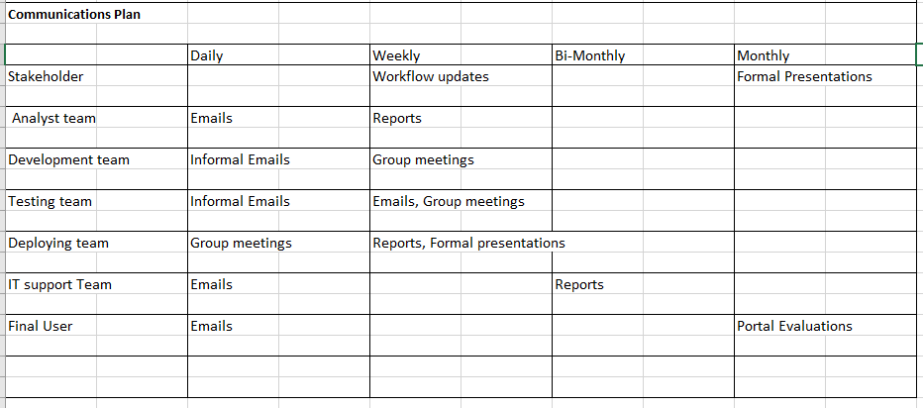

1. **Integration Management:**

Integration Management encompasses a diverse set of activities and processes that lead to the effective and successful implementation of project management. It involves several stages, starting with gathering information and progressing to creating a management plan, directing and executing the project, monitoring and controlling the project plan, and ultimately closing the project.

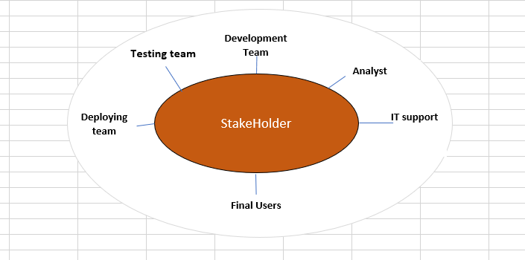

Project integration revolves around establishing coordination among all project elements. Conflicts may arise, causing delays or inadequate completion. It encompasses various aspects, including stakeholders, scope, quality, and outcomes, requiring accurate performance in each area.

The processes involved in project integration include developing the project charter and project management plan, directing and managing project work, managing project knowledge, and performing integrated changes. Once all changes are implemented, the project concludes with the wrap-up of related activities.

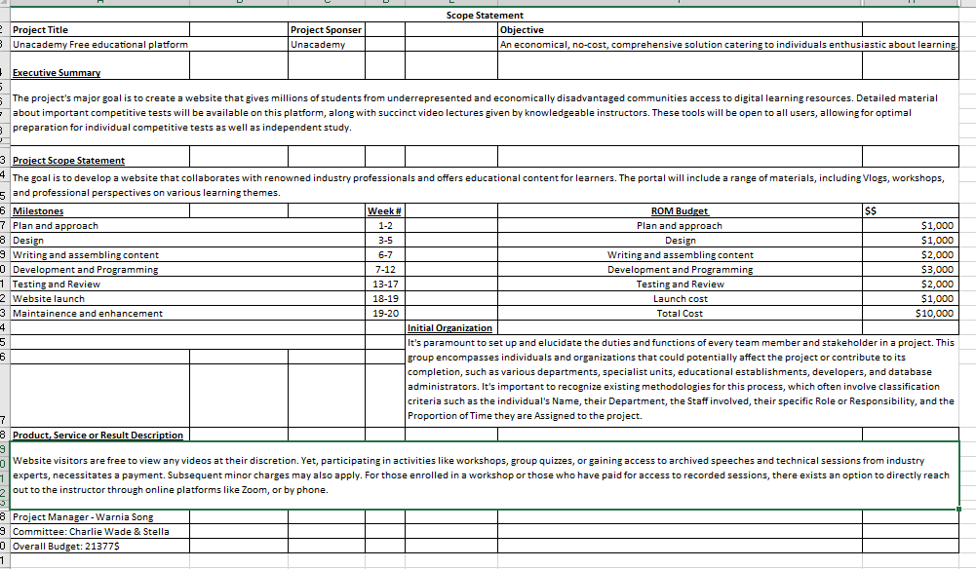

1. **Stakeholder Management:**

Project stakeholder management primarily involves organizing communication with stakeholders and ensuring their alignment with project expectations. It is a vital responsibility of project managers, who are accountable for various project-related tasks. Stakeholders are individuals or entities that invest significant resources in a project with the expectation of financial returns and a belief in its success. They hold considerable influence over the project's outcomes. Effective stakeholder management is crucial as it allows project managers to ensure that their initiatives meet the expectations of the stakeholders. Regularly sharing project updates with stakeholders is essential to maintain effective communication.

* 1. **Identify Stakeholders:** The initial step in stakeholder management is identifying the stakeholders who have an impact on the project. This includes listing all project participants, such as clients, investors, and other relevant individuals. The project manager is responsible for overseeing this process and creating a stakeholder register that captures details of each stakeholder's influence, role, and areas of interest. Project strategies are developed to focus on building and nurturing relationships, thereby ensuring the project's success.

**STAKEHOLDER MATRIX**

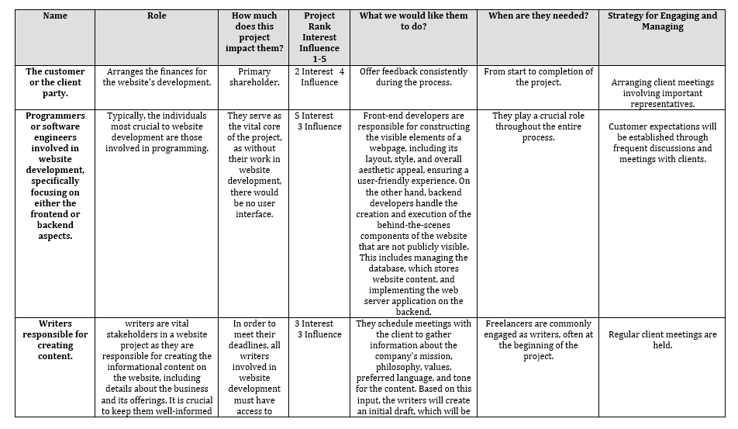

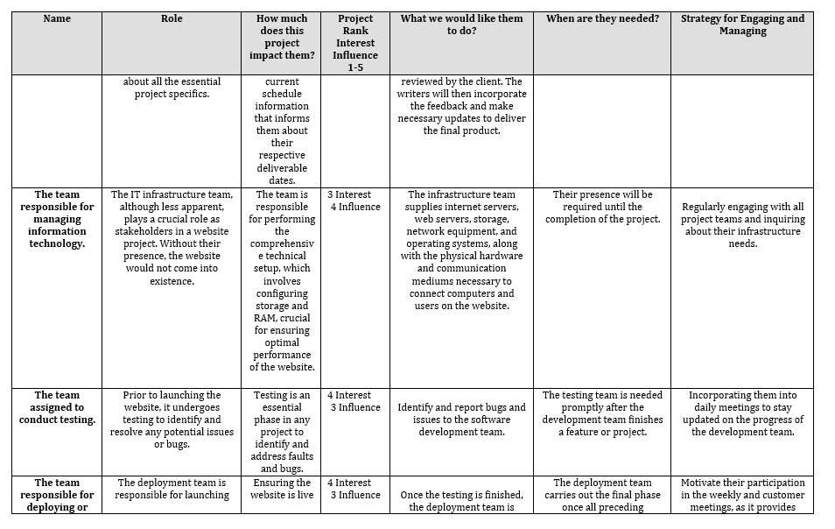

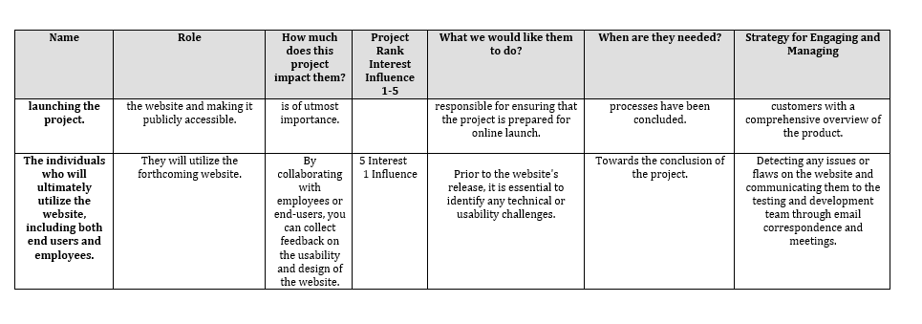

* 1. **Plan Stakeholders’ Engagement:** Stakeholder management is a crucial aspect of the overall management plan. Developing strategies to engage stakeholders is vital for project success. The stakeholder management plan can take either a formal or informal approach. This step in project management offers the benefit of providing a clear and practical plan to all project participants, ultimately benefiting the project as a whole. Based on the information obtained from the stakeholder registry, the project manager takes responsibility for identifying and involving the necessary individuals.



* 1. **Manage Stakeholder Engagement:** The primary objective of stakeholder management is to effectively handle communications with stakeholders to meet their expectations and promptly address any arising issues. The significant benefit of this approach is that it enhances support, ultimately driving the success of the project.
  2. **Monitor Stakeholder Engagement:** The main objectives of stakeholder engagement monitoring are to continuously monitor stakeholder relationships and adjust strategies as the project progresses. This process ensures the project's activities remain effective and efficient. It involves collecting data, assessing the level of stakeholder involvement, and devising new techniques to actively engage stakeholders, all aimed at maximizing project effectiveness.

1. **Project Procurement Management:**
   1. **Plan Procurement Management:** Currently, the project is in the planning phase. It is essential to have a statement of work for each contract involving external assistance. This serves as documented evidence for the contracted task, ensuring clarity and accountability throughout the engagement.
   2. **Conduct Procurements:** The procurement management plan encompasses the process of selecting sellers based on their responses. Its primary objective is to organize events such as conferences and evaluate potential sellers. Activities within this phase include issuing bid packages to prospective sellers, conducting bidder conferences, evaluating proposals from potential sellers, and ultimately selecting the winning proposal.
   3. **Control Procurements:** Controlled procurements involve closely monitoring contract work, evaluating project quality, making necessary adjustments, and ensuring that it meets expectations. In larger projects with extensive scope and higher complexity, a designated individual may be assigned to oversee the contracted work. This ensures effective management and oversight of the procurement process**.**
   4. **Close Procurements:** The closing phase of the procurement plan is known as "close procurements." It involves the systematic closure of the project and the preservation of all its components, including reports. This ensures that all necessary information is available for future reference. The activities involved in this phase are primarily administrative, focused on maintaining and preserving records for future use.

**13.Key Takeaways:**

* Together, we have duties and responsibilities. We had a defined structure and task allocation that kept the group on task.
* Communication is essential for any group effort; thus, we kept open lines of communication open throughout the project while also having clear instructions, careful listening, and frequent updates.
* We set deadlines to finish the group project on time since we needed to make several revisions to ensure that everyone was on the same page and to have a perfect project with the necessary corrections.
* We were aware of and made use of each team member's special skills to improve the effectiveness and quality of the project. Recognizing their contributions had a favorable effect on the team's performance.
* Every group member provided honest criticism for any contributions we made, and we made improvements as a result.

**14.Conclusion:**

In conclusion, the Unacademy project has revolutionized the educational landscape, providing an affordable and accessible platform for learners worldwide. Through innovative features, comprehensive course offerings, and expert educators, Unacademy has empowered countless individuals to pursue their educational goals. The diligent planning, efficient resource management, effective stakeholder engagement, and robust quality control measures have contributed to the project's success. Unacademy's commitment to continuous improvement and dedication to providing a seamless learning experience have solidified its position as a leading educational platform. As Unacademy continues to evolve and expand its offerings, it will undoubtedly continue to shape the future of education and inspire learners to achieve their full potential.